Display Module

Version 1.0

SHMT Co., Ltd.

REVISION HISTORY
Version | Detail(굴림/Verdana 10pt bold) | Name | Date
1.0

Technical documents
Copyright © 2006 Shmt Limited. All rights reserved.

Confidentiality Status
This document is NOT OPEN ACCESS. The distribution is restricted to certified company.
This document is CONFIDENTIAL.

Feedback on this document
If you have any comments on this document, please contact your channel to our company.

Shmt Web address
http://www.shmt.com

Contents

Detail contents
1. Display Module 9
1.1. Overview 9
1.1.1. Feature 9
2. Display & LCD Controller 10
2.1. Overview 10
2.1.1. Feature 10
2.1.2. Block Diagram 11
2.2. Operation 12
2.2.1. Overview 12
2.2.2. Timing 12
2.3. Signal Description 12
2.3.1. APB Signal 12
2.3.2. I2C BUS Signal 12
2.4. Register Description 12
2.4.1. Registers 13
2.4.2. LCDMCON (LCD Controller Master Control) Register 14
2.4.3. LCDMSTS (LCD Controller Master Status) Register 15
2.4.4. CCON (Cursor Control) Register 16
2.4.5. CBLND (Cursor Blending) Register 17
2.4.6. CBMOD (Cursor Blending Mode) Register 18
2.4.7. CBASE (Cursor Stride Base) Register 19
2.4.8. CADDR (Cursor Base Address) Register 20
2.4.9. CPALA (Cursor Palette Memory) Register 21
2.4.10. CADDR2 (Cursor Stream Control Address2) Register 22
2.4.11. CBLINK (Cursor Blink Control) Register 23
2.4.12. BGCOL (Background Color) Register 24
2.4.13. GCON (Graphics Surface Control) Register 25
2.4.14. GBLND (Graphics Blending) Register 26
2.4.15. GBMOD (Graphics Blending Mode) Register 27
2.4.16. GBASE (Graphics Stride Base) Register 28
2.4.17. GADDR (Graphics Stream Control Address) Register 29
2.4.18. GPALA (Graphics Palette Memory) Register 30
2.4.19. GGAMMA00 (Graphic Gamma LUT Index) Register 31
2.4.20. GGAMMA01 (Graphic Gamma LUT Index) Register 31
2.4.21. GGAMMA02 (Graphic Gamma LUT Index) Register 32
2.4.22. GGAMMA03 (Graphic Gamma LUT Index) Register 32
2.4.23. GGAMMA04 (Graphic Gamma LUT Index) Register 33
2.4.24. GGAMMA05 (Graphic Gamma LUT Index) Register 33
2.4.25. GGAMMA06 (Graphic Gamma LUT Index) Register 34
2.4.26. GGAMMA07 (Graphic Gamma LUT Index) Register 34
2.4.27. GGAMMA08 (Graphic Gamma LUT Index) Register 35
2.4.28. GGAMMA09 (Graphic Gamma LUT Index) Register 35
2.4.29. GGAMMA0A (Graphic Gamma LUT Index) Register 36
2.4.30. GGAMMA0B (Graphic Gamma LUT Index) Register 36
2.4.31. GGAMMA0C (Graphic Gamma LUT Index) Register 37
2.4.32. GGAMMA0D (Graphic Gamma LUT Index) Register 37
2.4.33. GGAMMA0E (Graphic Gamma LUT Index) Register 38
2.4.34. GGAMMA0F (Graphic Gamma LUT Index) Register 38
2.4.35. GGAMMA10 (Graphic Gamma LUT Index) Register 39
2.4.36. VCON (Video Surface Control) Register 40
2.4.37. VBLND (Video Blending) Register 41
2.4.38. VBMOD (Video Blend Mode) Register 42
2.4.39. VBASE (Video Stride Base) Register 43
2.4.40. VADDR (Video Stream Even Address) Register 44
2.4.41. VADDR2 (Video Stream Odd Address) Register 44
2.4.42. VGAMMA00 (Video Gamma LUT Index) Register 45
2.4.43. VGAMMA01 (Graphic Gamma LUT Index) Register 45
2.4.44. VGAMMA02 (Graphic Gamma LUT Index) Register 46
2.4.45. VGAMMA03 (Graphic Gamma LUT Index) Register 46
2.4.46. VGAMMA04 (Graphic Gamma LUT Index) Register 47
2.4.47. VGAMMA05 (Graphic Gamma LUT Index) Register 47
2.4.48. VGAMMA06 (Graphic Gamma LUT Index) Register 48
2.4.49. VGAMMA07 (Graphic Gamma LUT Index) Register 48
2.4.50. VGAMMA08 (Graphic Gamma LUT Index) Register 49
2.4.51. VGAMMA09 (Graphic Gamma LUT Index) Register 49
2.4.52. VGAMMA0A (Graphic Gamma LUT Index) Register 50
2.4.53. VGAMMA0B (Graphic Gamma LUT Index) Register 50
2.4.54. VGAMMA0C (Graphic Gamma LUT Index) Register 51
2.4.55. VGAMMA0D (Graphic Gamma LUT Index) Register 51
2.4.56. VGAMMA0E (Graphic Gamma LUT Index) Register 52
2.4.57. VGAMMA0F (Graphic Gamma LUT Index) Register 52
2.4.58. VGAMMA10 (Graphic Gamma LUT Index) Register 53
2.4.59. LCDCON (LCD Control) Register 54
2.4.60. VIDCON (Video Control) Register 55
2.4.61. HSYNCCON0 (Horizontal Sync0) Register 56
2.4.62. HSYNCCON1 (Horizontal Sync1) Register 56
2.4.63. VSYNCCON0 (Vertical Sync0) Register 57
2.4.64. VSYNCCON1 (Vertical Sync1) Register 57
2.5. Operation Diagram 58

Figures

Figure 2-1 Display Module Block Diagram 12
Figure 2-4 Pseudo SRAM Write Cycle Timing 13
Figure 2-2 LCDMCON Register Bits 15
Figure 2-3 LCDMSTS Register Bits 16
Figure 2-4 CCON Register Bits 17
Figure 2-4 CBLND Register Bits 18
Figure 2-4 CBMOD Register Bits 19
Figure 2-4 CBASE Register Bits 20
Figure 2-4 CADDR Register Bits 21
Figure 2-4 CPALA Register Bits 22
Figure 2-4 CADDR2 Register Bits 23
Figure 2-4 CBLINK Register Bits 24
Figure 2-4 BGCOL Register Bits 25
Figure 2-4 GCON Register Bits 26
Figure 2-4 GBLND Register Bits 27
Figure 2-4 GBMOD Register Bits 28
Figure 2-4 GBASE Register Bits 29
Figure 2-4 GADDR Register Bits 30
Figure 2-4 GPALA Register Bits 31
Figure 2-4 GGAMMA00 Register Bits 32
Figure 2-4 GGAMMA01 Register Bits 32
Figure 2-4 GGAMMA02 Register Bits 33
Figure 2-4 GGAMMA03 Register Bits 33
Figure 2-4 GGAMMA04 Register Bits 34
Figure 2-4 GGAMMA05 Register Bits 34
Figure 2-4 GGAMMA06 Register Bits 35
Figure 2-4 GGAMMA07 Register Bits 35
Figure 2-4 GGAMMA08 Register Bits 36
Figure 2-4 GGAMMA09 Register Bits 36
Figure 2-4 GGAMMA0A Register Bits 37
Figure 2-4 GGAMMA0B Register Bits 37
Figure 2-4 GGAMMA0C Register Bits 38
Figure 2-4 GGAMMA0D Register Bits 38
Figure 2-4 GGAMMA0ERegister Bits 39
Figure 2-4 GGAMMA0F Register Bits 39
Figure 2-4 GGAMMA10 Register Bits 40
Figure 2-4 VCON Register Bits 41
Figure 2-4 VBLND Register Bits 42
Figure 2-4 VBMOD Register Bits 43
Figure 2-4 VBASE Register Bits 44
Figure 2-4 VADDR Register Bits 45
Figure 2-4 VADDR2 Register Bits 45
Figure 2-4 VGAMMA00 Register Bits 46
Figure 2-4 VGAMMA01 Register Bits 46
Figure 2-4 VGAMMA02 Register Bits 47
Figure 2-4 VGAMMA03 Register Bits 47
Figure 2-4 VGAMMA04 Register Bits 48
Figure 2-4 VGAMMA05 Register Bits 48
Figure 2-4 VGAMMA06 Register Bits 49
Figure 2-4 VGAMMA07 Register Bits 49
Figure 2-4 VGAMMA08 Register Bits 50
Figure 2-4 VGAMMA09 Register Bits 50
Figure 2-4 VGAMMA0A Register Bits 51
Figure 2-4 VGAMMA0B Register Bits 51
Figure 2-4 VGAMMA0C Register Bits 52
Figure 2-4 VGAMMA0D Register Bits 52
Figure 2-4 VGAMMA0ERegister Bits 53
Figure 2-4 VGAMMA0F Register Bits 53
Figure 2-4 VGAMMA10 Register Bits 54
Figure 2-4 LCDCON Register Bits 55
Figure 2-4 VIDCON Register Bits 56
Figure 2-4 HSYNC0CON Register Bits 57
Figure 2-4 HSYNCCON1 Register Bits 57
Figure 2-4 VSYNCCON0 Register Bits 58
Figure 2-4 VSYNCCON1 Register Bits 58

Tables

Table 2-1 AMBA3 APB Signal 8
Table 2-2 PSRAM Signal 9
Table 2-4 Registers(Base Address : ???? ????h) 9
Table 2-5 PSRAMCON Register Description(Offset : 0000 0000h) 10
Table 2-6 PSRAMTCON Register Description(Offset : 0000 0004h) 10
Table 2-7 PSRAMTOUT Register Description(Offset : 0000 0008h) 11

Display Module

Overview

- BackGround Plane
- Video Plane
- Graphic Plane
- Cursor Plane
- Alpha blending(Global, Per Pixel)
- Chroma Key
- 감마보정

Plane

본 Display Module에는 4개의 Plane을 가지고 있다.
각각 Video, Graphic, Cursor, Background를 가지고 있다. 각 Plane이 지원하는 기능을 보면 다음과 같다.

Parameter | Planes
Parameter | Graphic | Video | Cursor | Background
Position (programmable) | 2 | 3 | 1 | 4
Resolution(max) | 4096x4096 | 4096x4096 | 1024x1024 | 1 color
RGB format | 8:8:8:8  5:5:5:1  5:6:5  8:8:8  8(Palletized) | YUV format  (4:2:2) | 3:3:2  5:5:5:1  5:6:5  8(Palletized) | 8:8:8
Bit per pixel | 8  16  32 | 16 | 8  16 | 24
Scaling factor | No | No | No | No
CSC | No | Yes | No | No
Gamma Correction | LUT(24x17),  Auto Gamma | LUT(24x17),  Auto Gamma | No | No
Global Alpha Blending | 8 | 8 | 8 | No
Per pixel Alpha Blending | 1 bit  8 bit | No | 1 bit | No
Destination Color Key | Yes | Yes | Yes | No
LCD Output Format | 16(RGB565)  18(RGB666)  24(RGB888)

Alpha Blending

Chroma Key

Gamma Correction

Display & LCD Controller

Overview

Feature

- BackGround/Video/Graphic1/Graphic0 Plane 지원
- 2048x2048 화면 처리 가능
- BackGround Plane은 단색만 지원
- Graphic0 Plane은 최대 1024x1024 사이즈 지원
- Graphic1/Video Plane은 최대 4096x4096 사이즈 지원
- Video, Graphic1, Graphic0 Plane은 Alpha blending(Global, Per Pixel)과 Chroma Key 지원
- Video/Graphic1 Plane 각각의 감마보정 기능 지원
- Graphic0/Graphic1 Plane에 8bpp 모드 지원을 위해 Palette RAM 필요
- TFT LCD Type 및 NTSC/PAL Video 출력 모드 지원

Block Diagram

Figure 2-1 Display Module Block Diagram
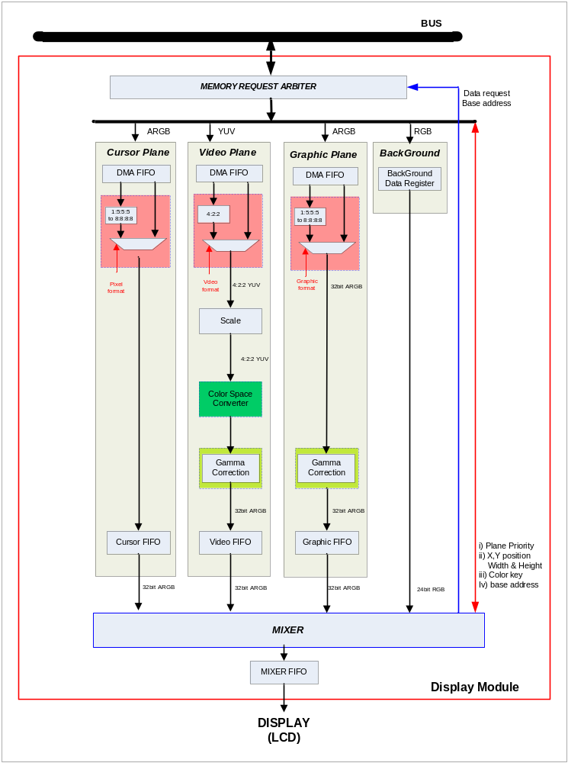

Operation

Overview

- BackGround/Video/Graphic/Cursor Plane 지원
- 2048x2048 화면 처리 가능
- BackGround Plane은 단색만 지원
- Cursor Plane은 최대 1024x1024 사이즈 지원
- Graphic/Video Plane은 최대 4096x4096 사이즈 지원
- Video, Graphic, Cursor Plane은 Alpha blending(Global, Per Pixel)과 Chroma Key 지원
- Video/Graphic Plane 각각의 감마보정 기능 지원
- Cursor/Graphic Plane에 8bpp 모드 지원을 위해 Palette RAM 필요
- TFT LCD Type 및 NTSC/PAL Video 출력 모드 지원

LCD Timing

Figure 2-2 LCD Timing and Register Setting

Graphic0 Plane

Figure 2-3 Graphic0 Plane Setting

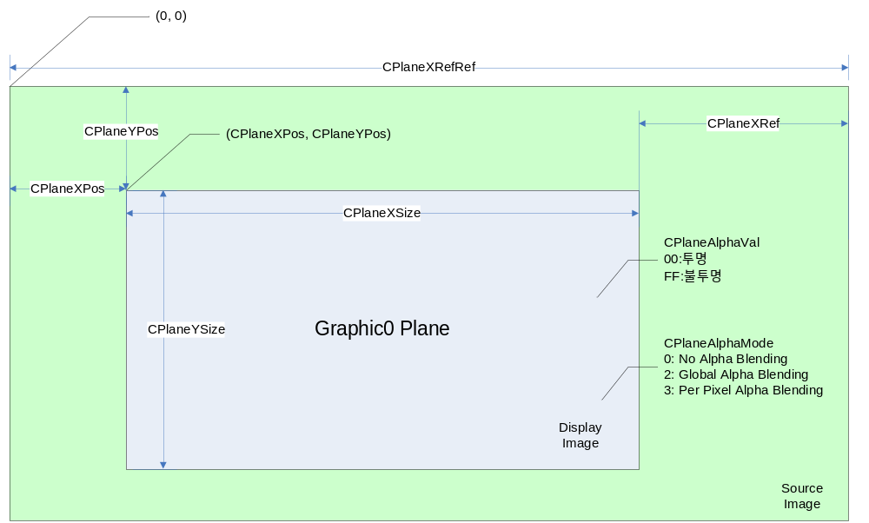

Graphic0 Plane은 최대 1024x1024의 이미지를 내보낼 수 있다. Alpha Blending을 지원하며 Gamma correction은 지원하지 않는다.

Graphic1 Plane

Figure 2-4 Graphic1 Plane Setting
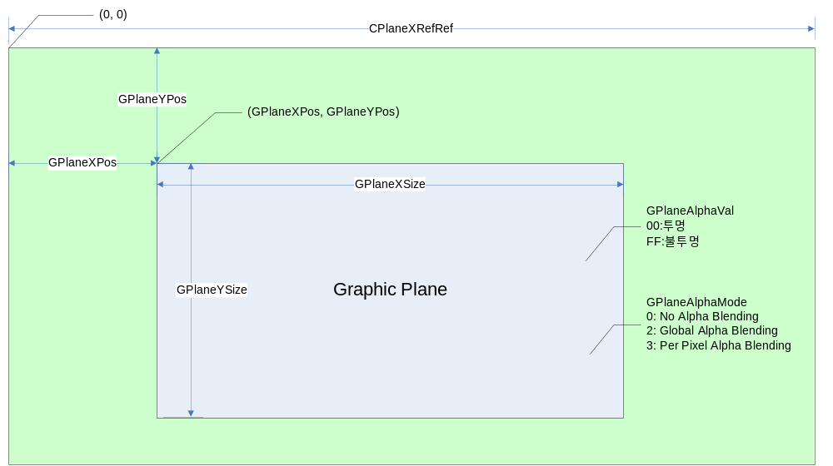

Graphic0 Plane은 최대 4096x4096의 이미지를 내보낼 수 있다.

Background Plane

Figure 2-5 Background Plane Setting
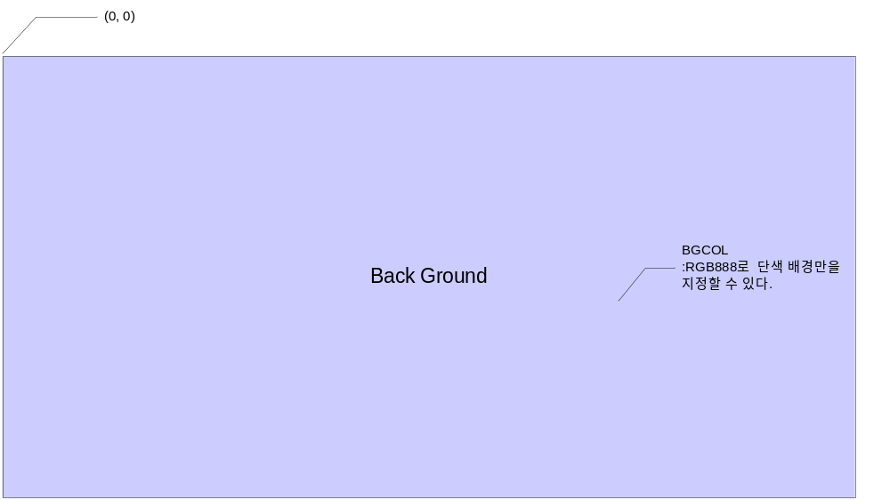
4개의 Plane중 우선 순위가 가장 낮은 Plane이다.
우선 순위가 높은 Plane이 투명하다면 Background 색상이 보이게 된다.

Video Plane

Figure 2-6 Video Plane Setting
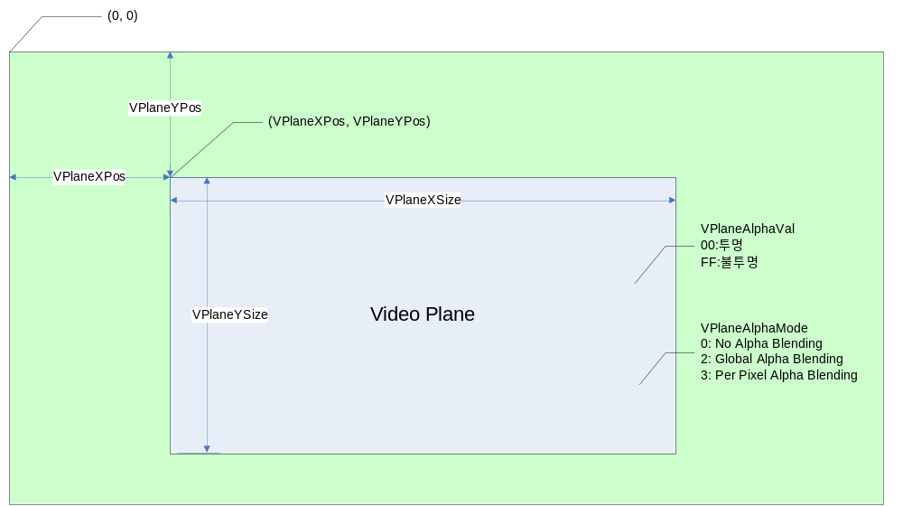

Signal Description

AXI Signal (생략)

APB Signal (생략)

Display Module Signal

Table 2-1 Display Module Signal
Signal Name | Direction | Description | Init. Value
LCDCLK | Input
LCDCLKo | Output
LCDHSync | Output
LCDVSync | Output
LCDDataEn | Output
LCDData | Output
VideoBPReq | Output
VideoBPAck | Input
VIFDataRequest | Output
VIFDataValid | Input
VIFDataIn | Input
FIFOClearBT | Output
LCDPDIV | Output
VideoSyncEnPCLK | Output
DmErrInt | Output
DmFrameStartInt | Output

Register Description

Registers

Table 2-2 Registers (Base Address : ???? ????h)
Offset | Name | R/W | Description | Init. Value
0000h | LCDMCON | RW | LCD Controller Master Control Register | 0000 0000h
0004h | LCDMSTS. | R | LCD Controller Master Status Register | 0000 0000h
0010h | GCON0 | RW | Graphic0 Control Register | 0000 0000h
0014h | GBLND0 | RW | Graphic0 Blending Register | 0000 0000h
0018h | GBMOD0 | RW | Graphic0 Blending Mode Register | 0000 0000h
001Ch | GBASE0 | RW | Graphic0 Stride Base Register | 0000 0000h
0020h | GADDR0 | RW | Graphic0 Stream Address Register
0024h | GPALM0 | RW | Graphic0 Palette Address Register | 0000 0000h
0028h | GADDR0_2 | RW | Graphic0 Stream Address 2 Register
002Ch | GBLINK | RW | Graphic0 Blink Control Register
0030h | BGCOL | RW | Background Color Register | 0000 0000h
0040h | GCON1 | RW | Graphics1 Surface Control Register | 0000 0000h
0044h | GBLND1 | RW | Graphics1 Blending Register | 0000 0000h
0048h | GBMOD1 | RW | Graphics1 Blending Mode Register | 0000 0000h
004Ch | GBASE1 | RW | Graphics1 Stride Base Register | 0000 0000h
0050h | GADDR1 | RW | Graphics1 Stream Address Register | 0000 0000h
0054h | GPALM1 | RW | Graphics1 Palette Address Register
0100h~0140h | GGAMMA | RW | Graphics1 Gamma Slope Register
0060h | VCON | RW | Video Surface Control Register
0064h | VBLND | RW | Video Blending Register
0068h | VBMOD | RW | Video Blending Mode Register
006Ch | VBASE | RW | Video Stride Base Register
0070h | VADDR | RW | Video Stream Even Address Register
0078h | VADDR2 | RW | Video Stream Odd Address Register
0200h~0240h | VGAMMA | RW | Video Gamma Slope Register
00E0h | LCDCON | RW | LCD Control Register
00E4h | VIDCON | RW | NTSC/PAL Control Regsiter
00E8h | VIDCON | RW | NTSC/PAL Control Register
00F0h | HSYNC0 | RW | Horizontal Sync0 Register
00F4h | HSYNC1 | RW | Horizontal Sync1 Register
00F8h | VSYNC0 | RW | Vertical Sync0 Register
00FCh | VSYNC1 | RW | Vertical Sync1 Register

LCDMCON (LCD Controller Master Control) Register

Figure 2-7 LCDMCON Register Bits
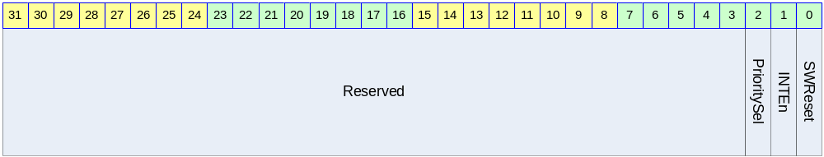

Table 2-3 LCDMCON Register Description (Offset : 0000 0000h)
Bits | Name | R/W | Description | Init. Value
[2] | PrioritySel | RW | Plane Position : 각 Plane에 대한 overlay priority bit. (Alpha Value 와 Colorkey setting에 따라 달라질 수 있음)  0 : Cursor>Video>Graphic>Background  1 : Cursor>Graphic>Video>Background | 00
[1] | INTEn | RW | Interrupt Enable  전송이 시작되면 인터럽트를 걸지를 선택  1: Interrupt Enable  0: Interrupt Disable | 0
[0] | SWReset | W | Reset LCD Controller  1 : Reset  0 : Set  1을 write 했을 때 1cycle후 자동으로 0이 된다. | 0

LCDMSTS (LCD Controller Master Status) Register

Figure 2-8 LCDMSTS Register Bits
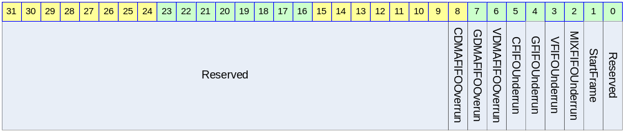

Table 2-4 LCDMSTS Register Description (Offset : 0000 0004h)
Bits | Name | R/W | Description | Init. Value
[8] | CDMAFIFOOverrun | R | Cursor Plane DMA FIFO OverRun  이 레지스터를 읽으면 0으로 클리어된다. | 0
[7] | GDMAFIFOOverrun | R | Video Plane DMA FIFO OverRun  이 레지스터를 읽으면 0으로 클리어된다. | 0
[6] | VDMAFIFOOverrun | R | Graphic Plane DMA FIFO OverRun  이 레지스터를 읽으면 0으로 클리어된다. | 0
[5] | CFIFOUnderrun | R | Cursor Plane FIFO UnderRun  이 레지스터를 읽으면 0으로 클리어된다. | 0
[4] | GFIFOUnderrun | R | Video Plane FIFO UnderRun  이 레지스터를 읽으면 0으로 클리어된다. | 0
[3] | VFIFOUnderrun | R | Graphic Plane FIFO UnderRun  이 레지스터를 읽으면 0으로 클리어된다. | 0
[2] | MIXFIFOUnderrun | R | Mixer FIFO UnderRun  이 레지스터를 읽으면 0으로 클리어된다. | 0
[1] | StartFrame | R | Start of Frame  이 레지스터를 읽으면 0으로 클리어된다. | 0

GCON0 (Graphic0 Control) Register

Figure 2-9 GCON0 Register Bits
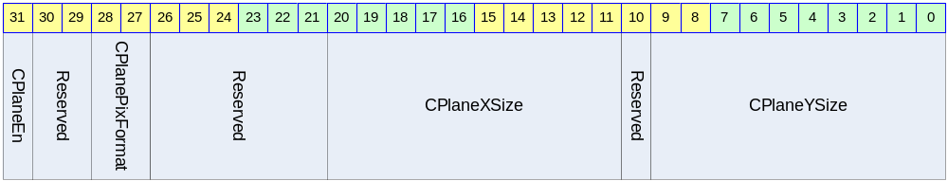

Table 2-5 GCON Register Description (Offset : 0000 0010h)
Bits | Name | R/W | Description | Init. Value
[31] | CPlaneEn | RW | Graphic0 Plane Enable | 0
[28:27] | CPlanePixFormat | RW | Graphic0 Pixel Format  0: 8bbp [RGB]  1: 8-bit rgb332 [RGB]  2: 1-bit alpha + 15bit rgb555[ARGB]  3: rgb565[RGB565] | 0
[20:11] | CPlaneXSize | RW | Graphic0 Surface Width | 64
[9:0] | CPlaneYSize | RW | Graphic0 Surface Height | 64

GBLND0 (Graphic0 Blending) Register

Figure 2-10 GBLND0 Register Bits
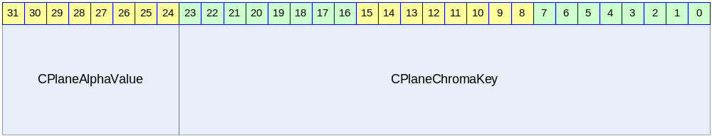

Table 2-6 GBLND0 Register Description (Offset : 0000 0014h)
Bits | Name | R/W | Description | Init. Value
[31:24] | CPlaneAlphaValue | RW | 0x00: Low Priority Plane Displayed  0xFF: Cursor Plane Displayed | 0
[23:0] | CPlaneChromaKey | RW | Color Key for Stream : RGB format | 0

GBMOD0 (Graphic0 Blending Mode) Register

Figure 2-11 GBMOD0 Register Bits
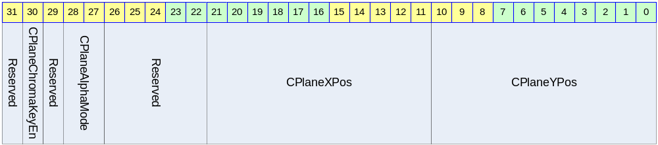

Table 2-7 GBMOD0 Register Description (Offset : 0000 0018h)
Bits | Name | R/W | Description | Init. Value
[30] | CPlaneChromaKeyEn | RW | Color Key Enable  0: Color keying disabled(Alpha Blend Mode)  1: Color Keying enable | 0
[28:27] | CPlaneAlphaMode | RW | 0 : No Alpha Blending  2 : Global Alpha Blending  3 : Per Pixel Alpha Blending  0x00 : Transparency  0xFF : opaque | 0
[21:11] | CPlaneXPos | RW | X Position Start : X position of top left corner of display | 0
[10:0] | CPlaneYPos | RW | Y Position Start : Y position of top left corner of display | 0

GBASE0 (Graphic0 Stride Base) Register

Figure 2-12 GBASE0 Register Bits
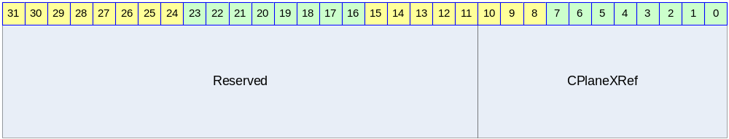

Table 2-8 GBASE0 Register Description (Offset : 0000 001Ch)
Bits | Name | R/W | Description | Init. Value
[10:0] | CPlaneXRef | RW | Source X Position Stride  Pixel Format(CPlanePixFormat)에 의하여  입력은 다음과 같이 넣어준다.  CPlaneXRefRef – CplaneXSizeRef  CPlaneXRefRef는  2, 3 : CPlaneXSrcSize>>1  0 : CPlaneXSrcSize>>2  CPlaneXSizeRef는  2, 3 : CPlaneXSize>>1  0 : CPlaneXSize>>2 | 1111111111b

GADDR0 (Graphic0 Base Address) Register

Figure 2-13 GADDR0 Register Bits
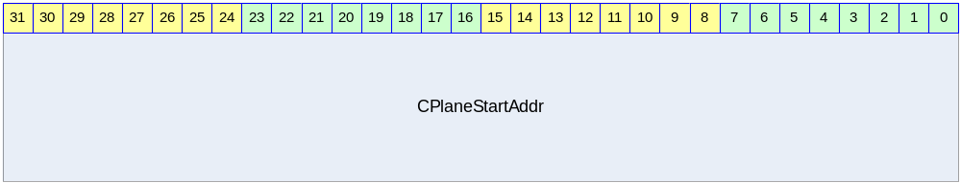

Table 2-9 GADDR0 Register Description(Offset : 0000 0020h)
Bits | Name | R/W | Description | Init. Value
[31:0] | CPlaneStartAddr | RW | Graphic0 Stream Control Address Register  CPlaneBASE + (CPlaneXStartRef + (CPlaneYStart * CPlaneXRefRef))<<2  CPlaneBASE : Frame Memory Base Address  CPlaneXStartRef : CPlanePixFormat에 의한 실제 DMA할 Source의 X Start Position  2, 3 : CPlaneXStart>>1  0 : CPlaneXStart>>2  (Write한 값과 Read한 값이 다르므로 주의할 것  Write한 값과 Read한 값을 비교하려면 Read한 값을 <<2 하여야 한다.) | 0

GPALA0 (Graphic0 Palette Memory) Register

Figure 2-14 GPALA0 Register Bits
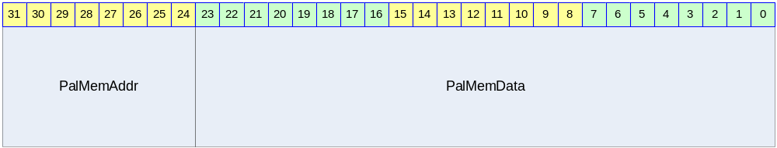

Table 2-10 GPALA Register Description (Offset : 0000 0024h)
Bits | Name | R/W | Description | Init. Value
[31:24] | PalMemAddr | RW | Palette Memory Address | 0
[23:0] | PalMemData | RW | Palette Memory

GADDR2 (Cursor Stream Control Address2) Register

Figure 2-15 CADDR2 Register Bits
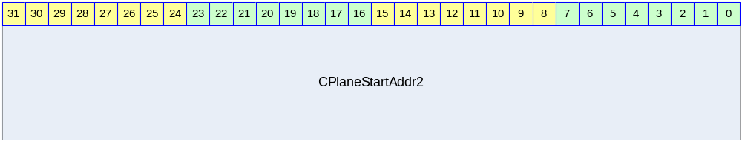

Table 2-11 CADDR2 Register Description (Offset : 0000 0028h)
Bits | Name | R/W | Description | Init. Value
[31:0] | CPlaneStartAddr2 | RW | Cursor Base Address 2 for Cursor Blinking CPlaneStartAddr2  (Write한 값과 Read한 값이 다르므로 주의할 것  실제로 write 하는 값의 하위 2bit는 00으로 고정된다. Read시 Write한 값과 Read한 값을 비교하려면 Read한 값을 <<2 하여야 한다.) | 0

CBLINK (Cursor Blink Control) Register

Figure 2-16 CBLINK Register Bits
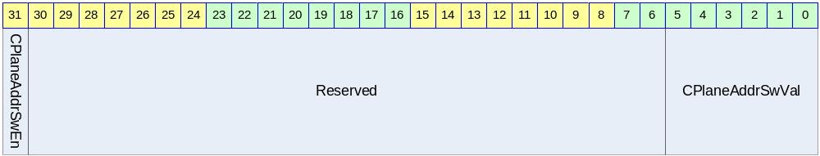

Table 2-12 CBLINK Register Description(Offset : 0000 002Ch)
Bits | Name | R/W | Description | Init. Value
[31] | CPlaneAddrSwEn | RW | Address Swap Enable  1로 set하면 CADDRSWVAL 마다 cursor data가 바뀐다.  Swap 되는 Address는 CPlaneStartAddr2이다. | 0
[5:0] | CPlaneAddrSwVal | RW | Address Swap Interval Value  Count by each VSYNC | 0

BGCOL (Background Color) Register

Figure 2-17 BGCOL Register Bits
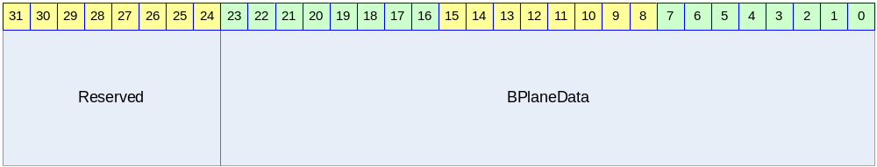

Table 2-13 BGCOL Register Description(Offset : 0000 0030h)
Bits | Name | R/W | Description | Init. Value
[23:0] | BPlaneData | RW | Background Color : RGB888 | 0

GCON1 (Graphics1 Surface Control) Register

Figure 2-18 GCON1 Register Bits
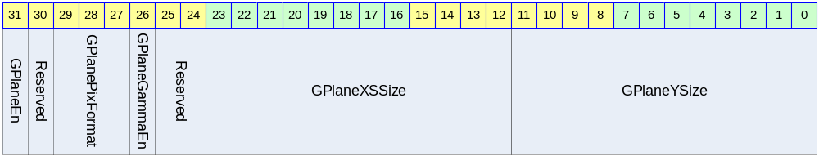

Table 2-14 GCON1 Register Description (Offset : 0000 0040h)
Bits | Name | R/W | Description | Init. Value
[31] | GPlaneEn | RW | Graphic1 Plane Enable | 0
[29:27] | GPlanePixFormat | RW | Graphics Pixel format  0b000 : 8bpp [RGB]  0b010 : 16-bit rgb565 [RGB]  0b011 : 1-bit alpha + 15-bit rgb555 [ARGB]  0b100 : 24-bit rgb888 [RGB]  0b101 : 8-bit alpha + 24-bit rgb888 [ARGB] | 0
[26] | GPlaneGammaEn | RW | Gamma LUT interpolation Enable  0 : bypass Gamma  1 : enable Gamma | 0
[23:12] | GPlaneXSize | RW | Graphics1 Surface Width (Maximum of 4096) | 2047
[11:0] | GPlaneYSize | RW | Graphics1 Surface Height (Maximum of 4096) | 2047

GBLND1 (Graphics1 Blending) Register

Figure 2-19 GBLND1 Register Bits
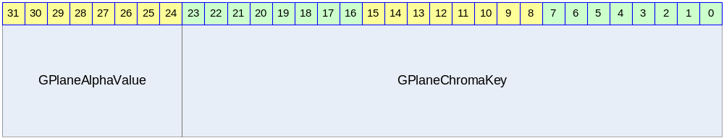

Table 2-15 GBLND1 Register Description (Offset : 0000 0044h)
Bits | Name | R/W | Description | Init. Value
[31:24] | GPlaneAlphaValue | RW | 0x00 : Low Priority Plane Displayed  0xFF : Current Plane Displayed | 0
[23:0] | GPlaneChromaKey | RW | Color Key for Stream : RGB format | 0

GBMOD1 (Graphics Blending Mode) Register

Figure 2-20 GBMOD1 Register Bits
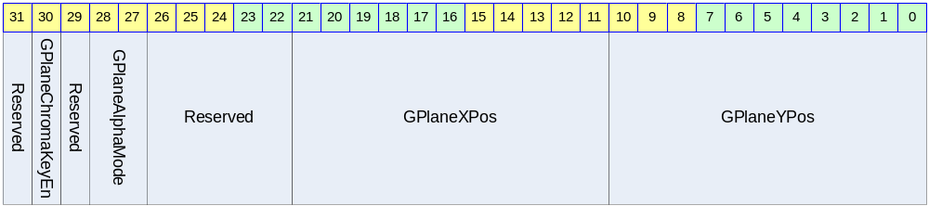

Table 2-16 GBMOD1 Register Description (Offset : 0000 0048h)
Bits | Name | R/W | Description | Init. Value
[30] | GPlaneChromaKeyEn | RW | Color Key Enable  0 : Color keying disabled  1 : Color keying enabled | 0
[28:27] | GPlaneAlphaMode | RW | 0 : No Alpha Blending  2 : Global Alpha Blending  3 : Per Pixel Alpha Blending  0x00 : Transparency  0xFF : opaque | 0
[21:11] | GPlaneXPos | RW | X Position Start : X position of top left corner of display | 0
[10:0] | GPlaneYPos | RW | Y Position Start : Y position of top left corner of display | 0

GBASE1 (Graphics1 Stride Base) Register

Figure 2-21 GBASE1 Register Bits
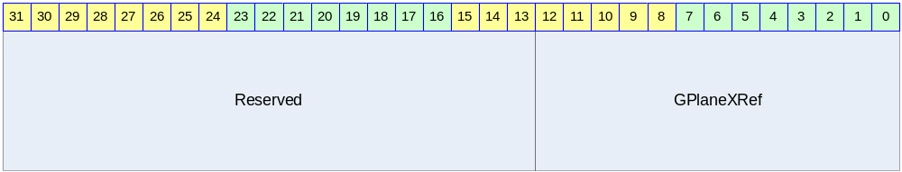

Table 2-17 GBASE1 Register Description(Offset : 0000 004Ch)
Bits | Name | R/W | Description | Init. Value
[12:0] | GPlaneXRef | RW | Source X Position Stride  GPlaneXRefRef - GPlaneXSizeRef | 0

GADDR1 (Graphics1 Stream Control Address) Register

Figure 2-22 GADDR1 Register Bits
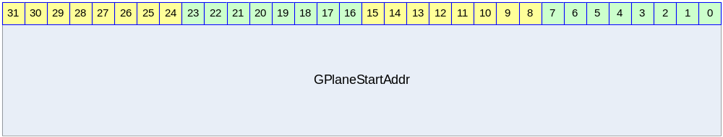

Table 2-18 GADDR1 Register Description(Offset : 0000 0050h)
Bits | Name | R/W | Description | Init. Value
[31:0] | GPlaneStartAddr | RW | Graphics Base Address  (Write 값과 Read값을 비교하기 위해서는 Read 값에 << 2를 해야한다) | 0

GPALA1 (Graphics1 Palette Memory) Register

Figure 2-23 GPALA1 Register Bits

Table 2-19 GPALA1 Register Description (Offset : 0000 005Ch)
Bits | Name | R/W | Description | Init. Value
[31:24] | PalMemAddr | RW | Palette Memory Address | 0
[23:0] | PalMemData | RW | Palette Memory Data

GGAMMA00 (Graphic Gamma LUT Index) Register

Figure 2-24 GGAMMA00 Register Bits
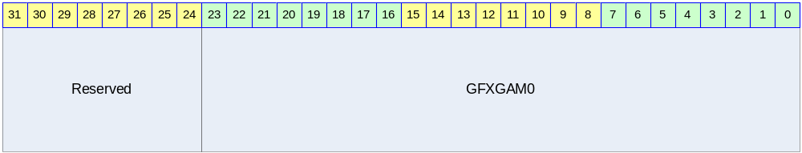

Table 2-20 GGAMMA00 Register Description(Offset : 0000 0100h)
Bits | Name | R/W | Description | Init. Value
[23:0] | GFXGAM0 | RW | Gamma Index0 | 0000 0000h

GGAMMA01 (Graphic Gamma LUT Index) Register

Figure 2-25 GGAMMA01 Register Bits
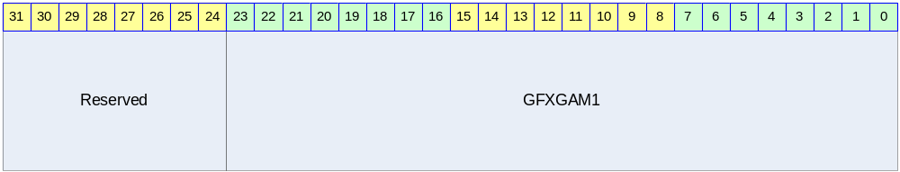

Table 2-21 GGAMMA01 Register Description(Offset : 0000 0104h)
Bits | Name | R/W | Description | Init. Value
[23:0] | GFXGAM1 | RW | Gamma Index1 | 0010 1010h

GGAMMA02 (Graphic Gamma LUT Index) Register

Figure 2-26 GGAMMA02 Register Bits
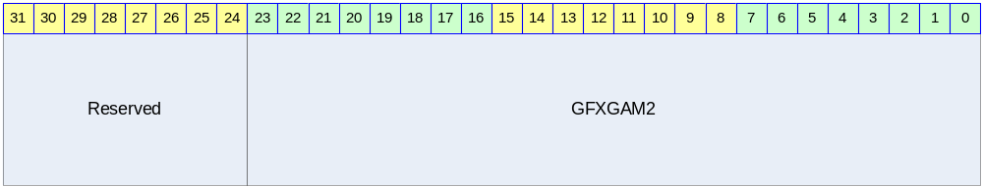

Table 2-22 GGAMMA02 Register Description(Offset : 0000 0108h)
Bits | Name | R/W | Description | Init. Value
[23:0] | GFXGAM2 | RW | Gamma Index2 | 0020 2020h

GGAMMA03 (Graphic Gamma LUT Index) Register

Figure 2-27 GGAMMA03 Register Bits
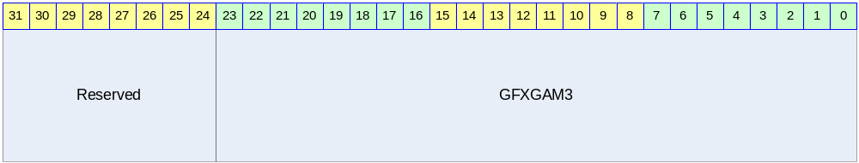

Table 2-23 GGAMMA03 Register Description(Offset : 0000 010Ch)
Bits | Name | R/W | Description | Init. Value
[23:0] | GFXGAM3 | RW | Gamma Index3 | 0030 3030h

GGAMMA04 (Graphic Gamma LUT Index) Register

Figure 2-28 GGAMMA04 Register Bits
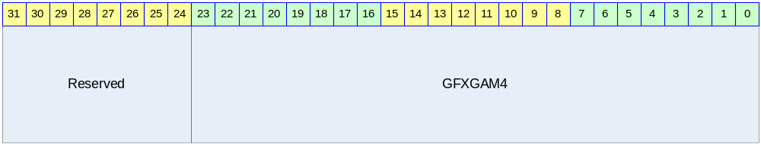

Table 2-24 GGAMMA04 Register Description(Offset : 0000 0110h)
Bits | Name | R/W | Description | Init. Value
[23:0] | GFXGAM4 | RW | Gamma Index4 | 0040 4040h

GGAMMA05 (Graphic Gamma LUT Index) Register

Figure 2-29 GGAMMA05 Register Bits
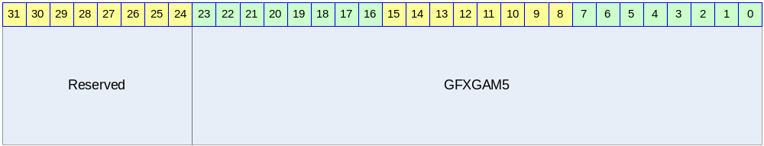

Table 2-25 GGAMMA05 Register Description(Offset : 0000 0114h)
Bits | Name | R/W | Description | Init. Value
[23:0] | GFXGAM5 | RW | Gamma Index5 | 0050 5050h

GGAMMA06 (Graphic Gamma LUT Index) Register

Figure 2-30 GGAMMA06 Register Bits
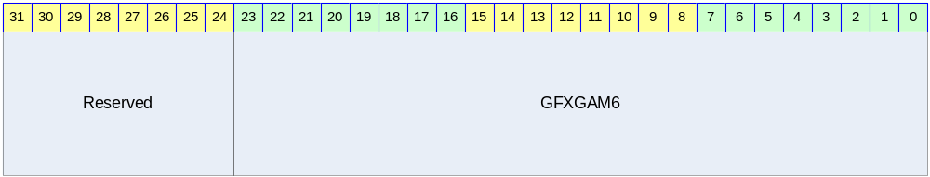

Table 2-26 GGAMMA06 Register Description(Offset : 0000 0118h)
Bits | Name | R/W | Description | Init. Value
[23:0] | GFXGAM6 | RW | Gamma Index6 | 0060 6060h

GGAMMA07 (Graphic Gamma LUT Index) Register

Figure 2-31 GGAMMA07 Register Bits
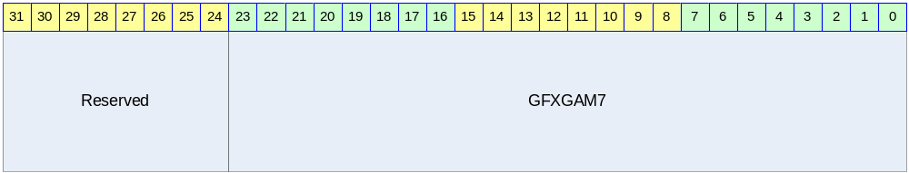

Table 2-27 GGAMMA07 Register Description(Offset : 0000 011Ch)
Bits | Name | R/W | Description | Init. Value
[23:0] | GFXGAM7 | RW | Gamma Index7 | 0070 7070h

GGAMMA08 (Graphic Gamma LUT Index) Register

Figure 2-32 GGAMMA08 Register Bits
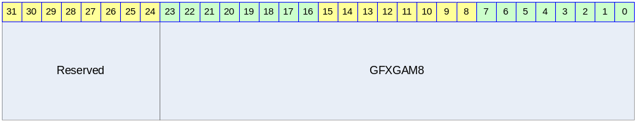

Table 2-28 GGAMMA08 Register Description(Offset : 0000 0120h)
Bits | Name | R/W | Description | Init. Value
[23:0] | GFXGAM8 | RW | Gamma Index8 | 0080 8080h

GGAMMA09 (Graphic Gamma LUT Index) Register

Figure 2-33 GGAMMA09 Register Bits
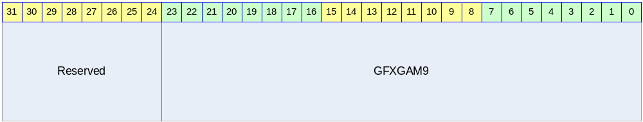

Table 2-29 GGAMMA09 Register Description(Offset : 0000 0124h)
Bits | Name | R/W | Description | Init. Value
[23:0] | GFXGAM9 | RW | Gamma Index9 | 0090 9090h

GGAMMA0A (Graphic Gamma LUT Index) Register

Figure 2-34 GGAMMA0A Register Bits
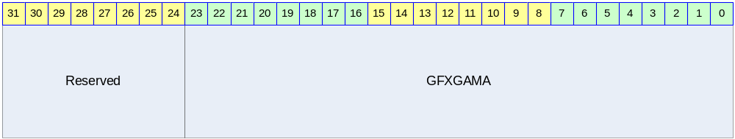

Table 2-30 GGAMMA10 Register Description(Offset : 0000 0128h)
Bits | Name | R/W | Description | Init. Value
[23:0] | GFXGAMA | RW | Gamma Index A | 00A0 A0A0h

GGAMMA0B (Graphic Gamma LUT Index) Register

Figure 2-35 GGAMMA0B Register Bits
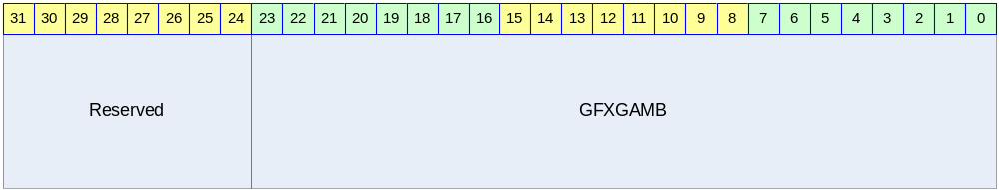

Table 2-31 GGAMMA07 Register Description(Offset : 0000 012Ch)
Bits | Name | R/W | Description | Init. Value
[23:0] | GFXGAMB | RW | Gamma Index B | 00B0 B0B0h

GGAMMA0C (Graphic Gamma LUT Index) Register

Figure 2-36 GGAMMA0C Register Bits
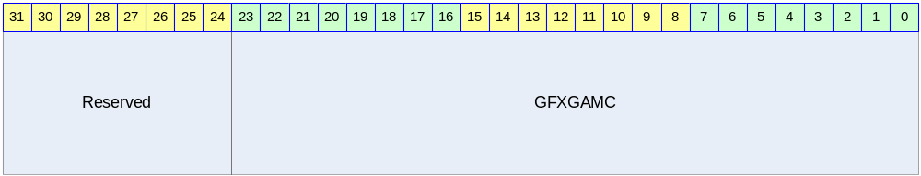

Table 2-32 GGAMMA0C Register Description(Offset : 0000 0130h)
Bits | Name | R/W | Description | Init. Value
[23:0] | GFXGAMC | RW | Gamma Index C | 00C0 C0C0h

GGAMMA0D (Graphic Gamma LUT Index) Register

Figure 2-37 GGAMMA0D Register Bits
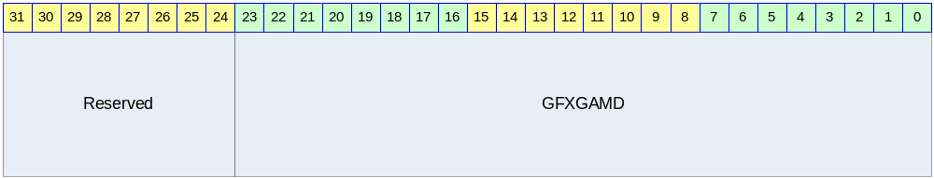

Table 2-33 GGAMMA0DRegister Description(Offset : 0000 0134h)
Bits | Name | R/W | Description | Init. Value
[23:0] | GFXGAMD | RW | Gamma Index D | 00D0 D0D0h

GGAMMA0E (Graphic Gamma LUT Index) Register

Figure 2-38 GGAMMA0ERegister Bits
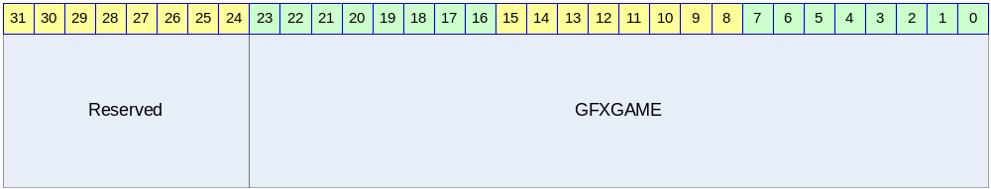

Table 2-34 GGAMMA0E Register Description(Offset : 0000 0138h)
Bits | Name | R/W | Description | Init. Value
[23:0] | GFXGAME | RW | Gamma Index E | 00E0 E0E0h

GGAMMA0F (Graphic Gamma LUT Index) Register

Figure 2-39 GGAMMA0F Register Bits
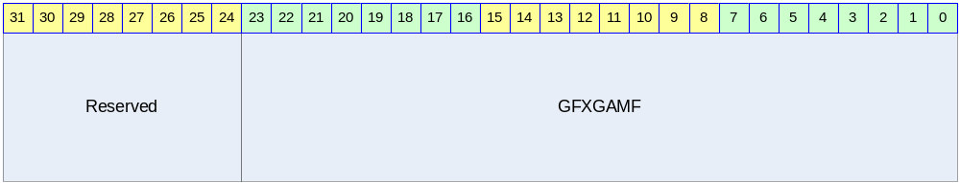

Table 2-35 GGAMMA0F Register Description(Offset : 0000 013Ch)
Bits | Name | R/W | Description | Init. Value
[23:0] | GFXGAMF | RW | Gamma Index F | 00F0 F0F0h

GGAMMA10 (Graphic Gamma LUT Index) Register

Figure 2-40 GGAMMA10 Register Bits
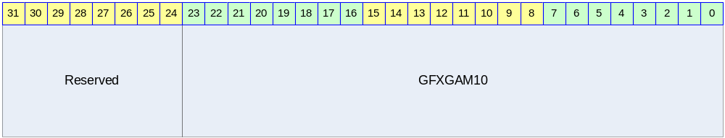

Table 2-36 GGAMMA10 Register Description(Offset : 0000 0140h)
Bits | Name | R/W | Description | Init. Value
[23:0] | GFXGAM10 | RW | Gamma Index 10 | 00FF FFFFh

VCON (Video Surface Control) Register

Figure 2-41 VCON Register Bits
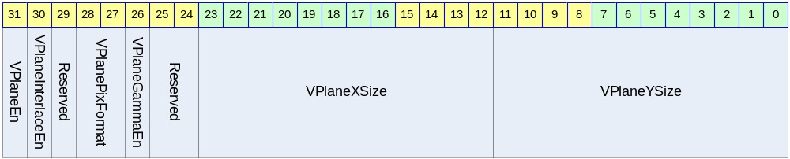

Table 2-37 VCON Register Description(Offset : 0000 060h)
Bits | Name | R/W | Description | Init. Value
[31] | VPlaneEn | RW | Video Plane Enable | 0
[30] | VPlaneInterfaceEn | RW | Interface Video Enable | 0
[28:27] | VPlanePixFormat | RW | Video Pixel format  0b00 : 16bit YUV 4:2:2 UY0VY1 (U lsb) [UYVY / UYNV]  0b01 : 16-bi t YUV 4:2:2 VY0UY1 (V lsb)  0b10 : 16-bit YUV 4:2:2 Y0UY1V (Y0 lsb) [YUY2 / YUNV / V422]  0b11 : 16-bit YUV 4:2:2 Y0VY1U (Y0 lsb) [YVYU] | 0
[26] | VPlaneGammaEn | RW | Gamma LUT interpolation Enable  0 : bypass Gamma  1 : enable Gamma | 0
[23:12] | VPlaneXSize | RW | Video Surface Width (Maximum of 2047) | 2047
[11:0] | VPlaneYSize | RW | Video Surface Height (Maximum of 2047) | 2047

VBLND (Video Blending) Register

Figure 2-42 VBLND Register Bits
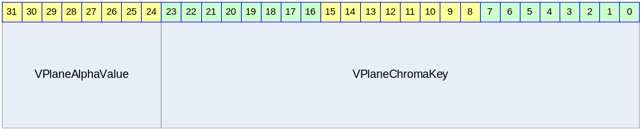

Table 2-38 VBLND Register Description(Offset : 0000 0064h)
Bits | Name | R/W | Description | Init. Value
[31:24] | VPlaneAlphaValue | RW | 0x00 : Low Priority Plane Displayed  0xFF : Current Plane Displayed | 0
[23:0] | VPlaneChromaKey | RW | Color Key for Stream : RGB format | 0

VBMOD (Video Blend Mode) Register

Figure 2-43 VBMOD Register Bits
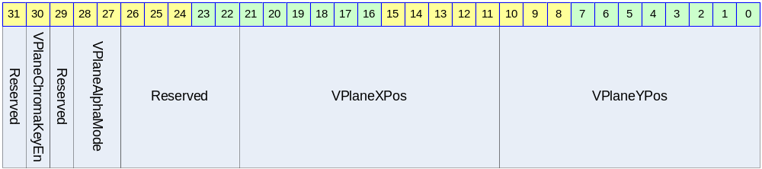

Table 2-39 VBMOD Register Description (Offset : 0000 0068h)
Bits | Name | R/W | Description | Init. Value
[30] | VPlaneChromaKeyEn | RW | Color Key Enable  0 : Color keying disabled  1 : Color keying enabled | 0
[28:27] | VPlaneAlphaMode | RW | 0 : No Alpha Blending  2 : Global Alpha Blending  0x00 : Transparency  0xFF : opaque | 0
[21:11] | VPlaneXPos | RW | X Position Start : X position of top left corner of display | 0
[10:0] | VPlaneYPos | RW | Y Position Start : Y position of top left corner of display | 0

VBASE (Video Stride Base) Register

Figure 2-44 VBASE Register Bits
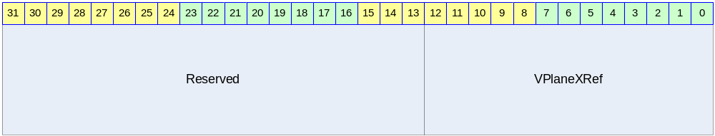

Table 2-40 VBASE Register Description (Offset : 0000 006Ch)
Bits | Name | R/W | Description | Init. Value
[12:0] | VPlaneXRef | RW | Source X Position Stride  VPlaneXRefRef - VPlaneXSizeRef | 0

VADDR (Video Stream Even Address) Register

Figure 2-45 VADDR Register Bits
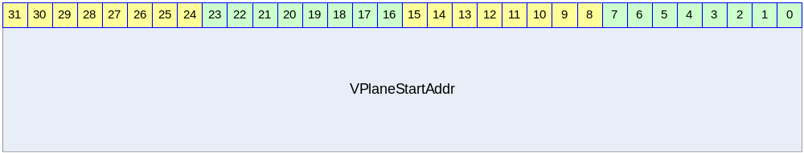

Table 2-41 VADDR Register Description(Offset : 0000 0070h)
Bits | Name | R/W | Description | Init. Value
[31:0] | VPlaneStartAddr | RW | Video Base Even Address  (쓰여지는 값과 읽히는 값에 차이가 있음) | 0

VADDR2 (Video Stream Odd Address) Register

Figure 2-46 VADDR2 Register Bits
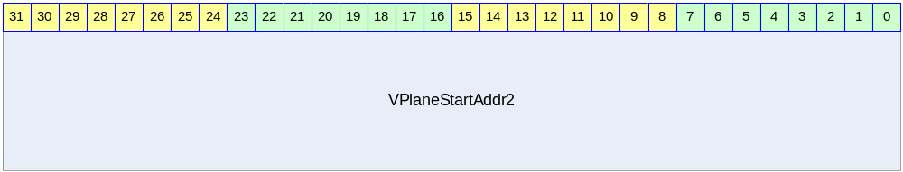

Table 2-42 VADDR2 Register Description(Offset : 0000 0074h)
Bits | Name | R/W | Description | Init. Value
[31:0] | VPlaneStartAddr2 | RW | Video Base Odd Address  (쓰여지는 값과 읽히는 값에 차이가 있음) | 0

VGAMMA00 (Video Gamma LUT Index) Register

Figure 2-47 VGAMMA00 Register Bits
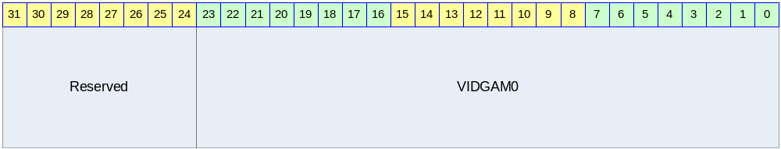

Table 2-43 VGAMMA00 Register Description(Offset : 0000 0200h)
Bits | Name | R/W | Description | Init. Value
[23:0] | VIDGAM0 | RW | Gamma Index0 | 0000 0000h

VGAMMA01 (Graphic Gamma LUT Index) Register

Figure 2-48 VGAMMA01 Register Bits
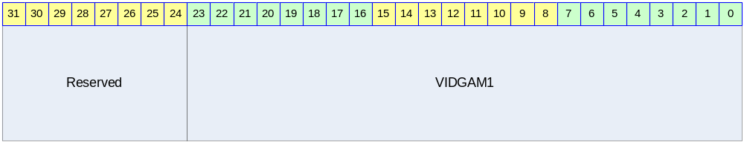

Table 2-44 VGAMMA01 Register Description(Offset : 0000 0204h)
Bits | Name | R/W | Description | Init. Value
[23:0] | VIDGAM1 | RW | Gamma Index1 | 0010 1010h

VGAMMA02 (Graphic Gamma LUT Index) Register

Figure 2-49 VGAMMA02 Register Bits
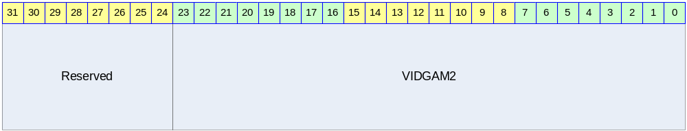

Table 2-45 VGAMMA02 Register Description(Offset : 0000 0208h)
Bits | Name | R/W | Description | Init. Value
[23:0] | VIDGAM2 | RW | Gamma Index2 | 0020 2020h

VGAMMA03 (Graphic Gamma LUT Index) Register

Figure 2-50 VGAMMA03 Register Bits
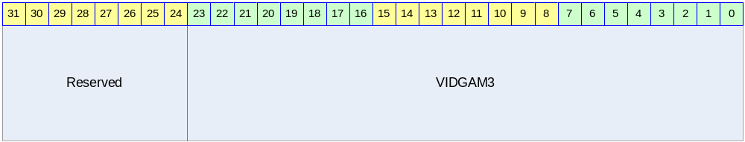

Table 2-46 VGAMMA03 Register Description(Offset : 0000 020Ch)
Bits | Name | R/W | Description | Init. Value
[23:0] | VIDGAM3 | RW | Gamma Index3 | 0030 3030h

VGAMMA04 (Graphic Gamma LUT Index) Register

Figure 2-51 VGAMMA04 Register Bits
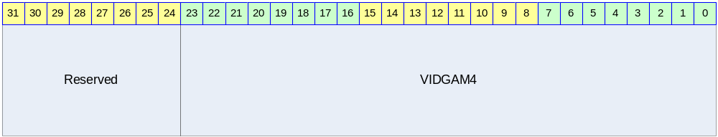

Table 2-47 VGAMMA04 Register Description(Offset : 0000 0210h)
Bits | Name | R/W | Description | Init. Value
[23:0] | VIDGAM4 | RW | Gamma Index4 | 0040 4040h

VGAMMA05 (Graphic Gamma LUT Index) Register

Figure 2-52 VGAMMA05 Register Bits
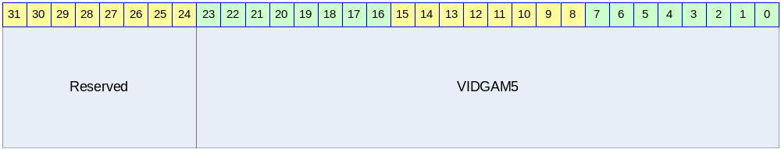

Table 2-48 VGAMMA05 Register Description(Offset : 0000 0214h)
Bits | Name | R/W | Description | Init. Value
[23:0] | VIDGAM5 | RW | Gamma Index5 | 0050 5050h

VGAMMA06 (Graphic Gamma LUT Index) Register

Figure 2-53 VGAMMA06 Register Bits
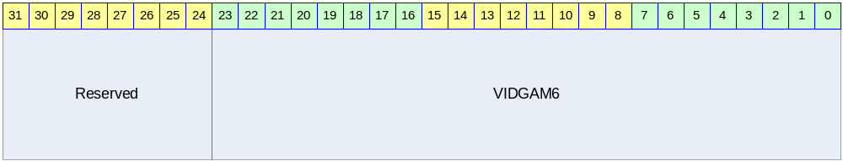

Table 2-49 VGAMMA06 Register Description(Offset : 0000 0218h)
Bits | Name | R/W | Description | Init. Value
[23:0] | VIDGAM6 | RW | Gamma Index6 | 0060 6060h

VGAMMA07 (Graphic Gamma LUT Index) Register

Figure 2-54 VGAMMA07 Register Bits
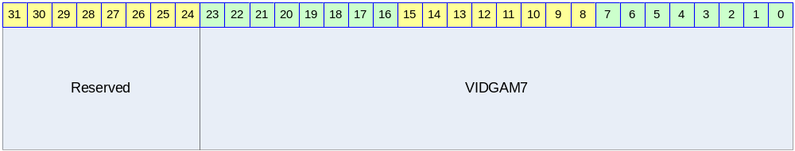

Table 2-50 VGAMMA07 Register Description(Offset : 0000 021Ch)
Bits | Name | R/W | Description | Init. Value
[23:0] | VIDGAM7 | RW | Gamma Index7 | 0070 7070h

VGAMMA08 (Graphic Gamma LUT Index) Register

Figure 2-55 VGAMMA08 Register Bits
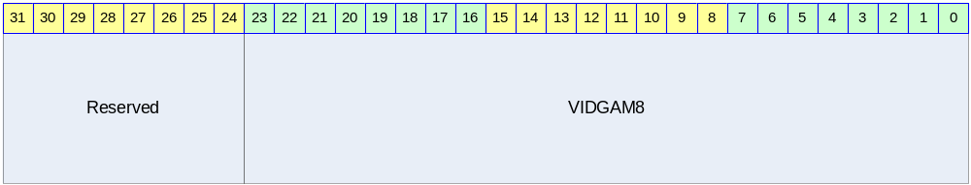

Table 2-51 VGAMMA08 Register Description(Offset : 0000 0220h)
Bits | Name | R/W | Description | Init. Value
[23:0] | VIDGAM8 | RW | Gamma Index8 | 0080 8080h

VGAMMA09 (Graphic Gamma LUT Index) Register

Figure 2-56 VGAMMA09 Register Bits
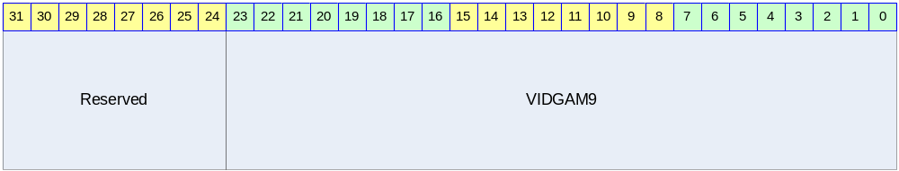

Table 2-52 VGAMMA09 Register Description(Offset : 0000 0224h)
Bits | Name | R/W | Description | Init. Value
[23:0] | VIDGAM9 | RW | Gamma Index9 | 0090 9090h

VGAMMA0A (Graphic Gamma LUT Index) Register

Figure 2-57 VGAMMA0A Register Bits
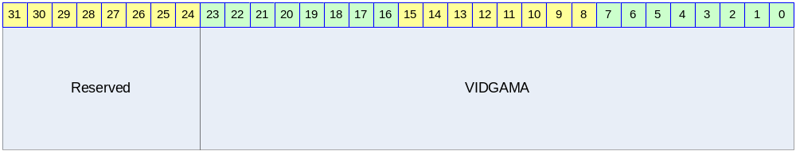

Table 2-53 VGAMMA10 Register Description(Offset : 0000 0228h)
Bits | Name | R/W | Description | Init. Value
[23:0] | VIDGAMA | RW | Gamma Index A | 00A0 A0A0h

VGAMMA0B (Graphic Gamma LUT Index) Register

Figure 2-58 VGAMMA0B Register Bits
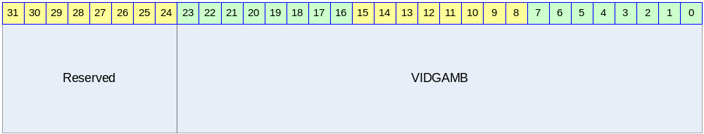

Table 2-54 VGAMMA07 Register Description(Offset : 0000 022Ch)
Bits | Name | R/W | Description | Init. Value
[23:0] | VIDGAMB | RW | Gamma Index B | 00B0 B0B0h

VGAMMA0C (Graphic Gamma LUT Index) Register

Figure 2-59 VGAMMA0C Register Bits
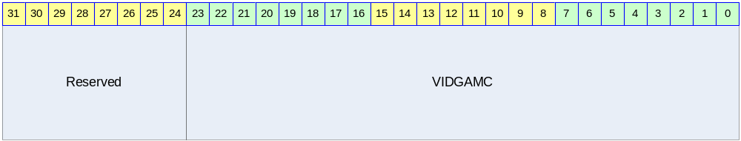

Table 2-55 VGAMMA0C Register Description(Offset : 0000 0230h)
Bits | Name | R/W | Description | Init. Value
[23:0] | VIDGAMC | RW | Gamma Index C | 00C0 C0C0h

VGAMMA0D (Graphic Gamma LUT Index) Register

Figure 2-60 VGAMMA0D Register Bits
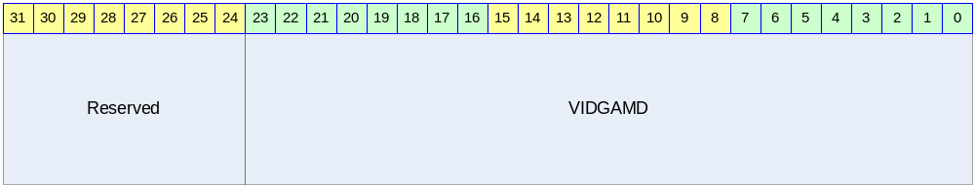

Table 2-56 VGAMMA0DRegister Description(Offset : 0000 0234h)
Bits | Name | R/W | Description | Init. Value
[23:0] | VIDGAMD | RW | Gamma Index D | 00D0 D0D0h

VGAMMA0E (Graphic Gamma LUT Index) Register

Figure 2-61 VGAMMA0ERegister Bits
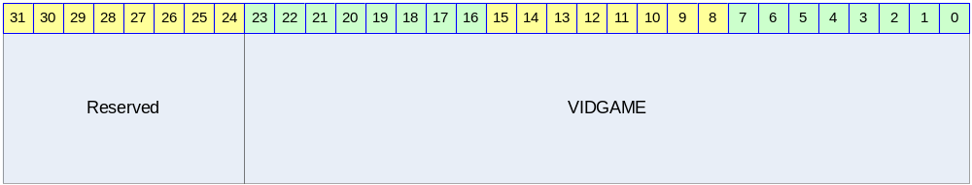

Table 2-57 VGAMMA0E Register Description(Offset : 0000 0238h)
Bits | Name | R/W | Description | Init. Value
[23:0] | VIDGAME | RW | Gamma Index E | 00E0 E0E0h

VGAMMA0F (Graphic Gamma LUT Index) Register

Figure 2-62 VGAMMA0F Register Bits
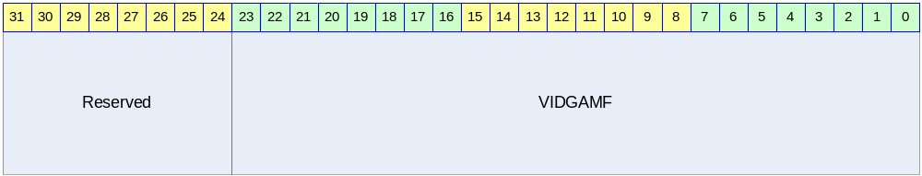

Table 2-58 VGAMMA0F Register Description(Offset : 0000 023Ch)
Bits | Name | R/W | Description | Init. Value
[23:0] | VIDGAMF | RW | Gamma Index F | 00F0 F0F0h

VGAMMA10 (Graphic Gamma LUT Index) Register

Figure 2-63 VGAMMA10 Register Bits
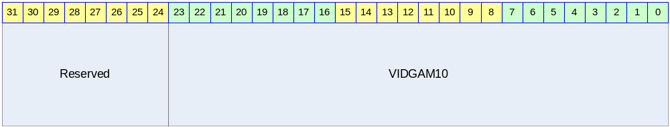

Table 2-59 VGAMMA10 Register Description(Offset : 0000 0240h)
Bits | Name | R/W | Description | Init. Value
[23:0] | VIDGAM10 | RW | Gamma Index 10 | 00FF FFFFh

LCDCON (LCD Control) Register

Figure 2-64 LCDCON Register Bits
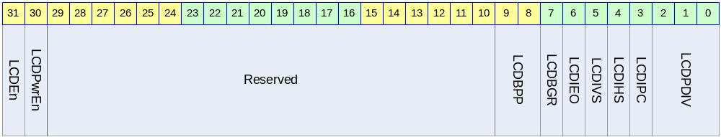

Table 2-60 LCDCON Register Description(Offset : 0000 00E0h)
Bits | Name | R/W | Description | Init. Value
[31] | LCDEn | RW | LCD Sync Enable | 0
[30] | LCDPwrEn | RW | LCD Power Enable | 0
[9:8] | LCDBPP | RW | LCD Pixel Format  0 : 16bpp  1 : 18bpp  2 : 24bpp | 0
[7] | LCDBGR | RW | R/B Swap Enable | 0
[6] | LCDIEO | RW | Invert Write Enable | 0
[5] | LCDIVS | RW | Invert VSYNC | 0
[4] | LCDIHS | RW | Invert HSYNC | 0
[3] | LCDIPS | RW | Invert Pixel Clock | 0
[2:0] | LCDPDIV | RW | 0 : Bypass System Clock  1 : Divide by 2 System Clock  2 : Divide by 3 System Clock  3 : Divide by 4 System Clock  4 : Divide by 6 System Clock  5 : Divide by 8 System Clock  6 : Divide by 16 System Clock  7 : Divide by 32 System Clock | 0

VIDCON (Video Control) Register

Figure 2-65 VIDCON Register Bits
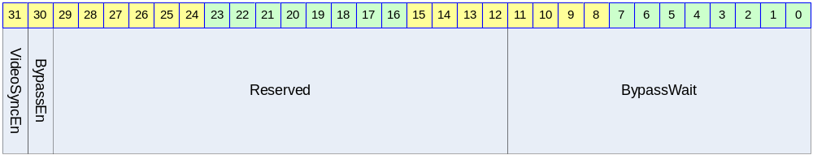

Table 2-61 VIDCON Register Description(Offset : 0000 00E4h)
Bits | Name | R/W | Description | Init. Value
[31] | VideoSyncEn | RW | Video Sync Enable | 0
[30] | BypassEn | RW | External Video Bypass Enable | 0
[11:0] | BypassWait | RW | External Video Bypass Wait Cycle  Video Clock/16 값을 설정 한다. | 0

LCDLECON (LCD Line End Control) Register

Figure 2-66 LCDLECON Register Bits

Table 2-62 LCDLECON Register Description(Offset : 0000 00E8h)
Bits | Name | R/W | Description | Init. Value
[9:8] | LcdVComp | RW |  | 0
[7] | LEE | RW |  | 0
[6:0] | LED | RW |  | 0

HSYNCCON0 (Horizontal Sync0) Register

Figure 2-67 HSYNC0CON Register Bits
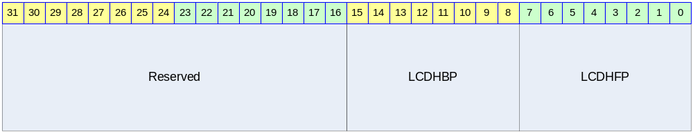

Table 2-63 HSYNCCON0 Register Description(Offset : 0000 00F0h)
Bits | Name | R/W | Description | Init. Value
[15:8] | LCDHBP | RW | Horizontal Back Porch | 0
[7:0] | LCDHFP | RW | Horizontal Front Porch | 0

HSYNCCON1 (Horizontal Sync1) Register

Figure 2-68 HSYNCCON1 Register Bits
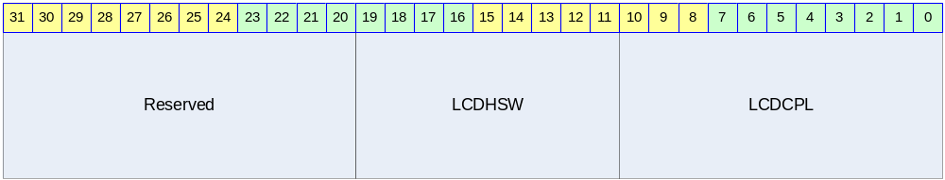

Table 2-64 HSYNCCON1 Register Description(Offset : 0000 00F4h)
Bits | Name | R/W | Description | Init. Value
[19:11] | LCDHSW | RW | Horizontal Sync Pulse Width | 0
[10:0] | LCDCPL | RW | Display Pixel per Line | 2047

VSYNCCON0 (Vertical Sync0) Register

Figure 2-69 VSYNCCON0 Register Bits
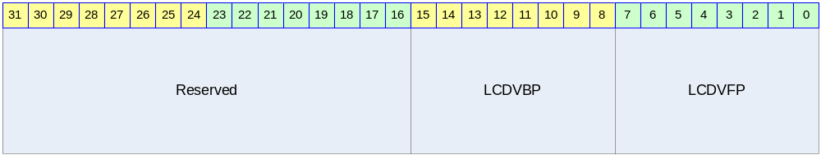

Table 2-65 VSYNCCON0 Register Description(Offset : 0000 00F8h)
Bits | Name | R/W | Description | Init. Value
[15:8] | LCDVBP | RW | Vertical Back Porch | 0
[7:0] | LCDVFP | RW | Vertical Front Porch | 0

VSYNCCON1 (Vertical Sync1) Register

Figure 2-70 VSYNCCON1 Register Bits
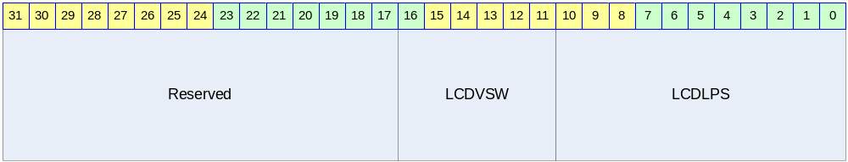

Table 2-66 VSYNCCON1 Register Description(Offset : 0000 00FCh)
Bits | Name | R/W | Description | Init. Value
[16:11] | LCDVSW | RW | Vertical Sync Pulse Width | 0
[10:0] | LCDLPS | RW | Line Display Period | 2047

Operation Diagram

